**Chapter 3**

**Vector-Valued Functions**

**3.2 Calculus of Vector-Valued Functions**

**Section Exercises**

**Compute the derivatives of the vector-valued functions.**

41. 

Answer: 

43.  A sketch of the graph is shown here. Notice the varying periodic nature of the graph.

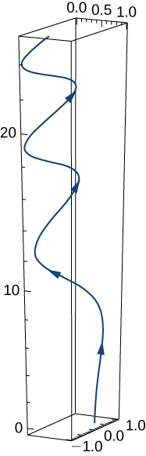

Answer: 

45. 

Answer: 

47. 

Answer: 

49. 

Answer: 

**For the following problems, find a tangent vector at the indicated value of *t*.**

51. 

Answer: 

53.  ;

Answer: 

**Find the unit tangent vector for the following parameterized curves.**

55.  

Answer: 

57. 

Answer: 

**Let  and  Here is the graph of the function:**

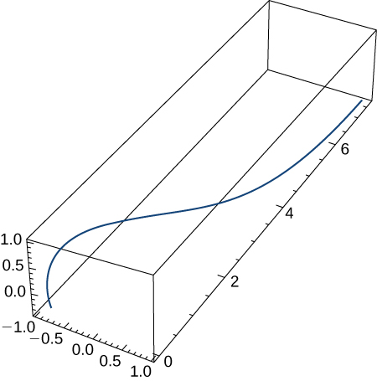

**Find the following.**

59. 

Answer: 

61. 

Answer: 

63. Find 

Answer: 

65. The position vector of a particle is 

1. Graph the position function and display a view of the graph that illustrates the asymptotic behavior of the function.
2. Find the velocity as *t* approaches but is not equal to  (if it exists).

Answer: a.

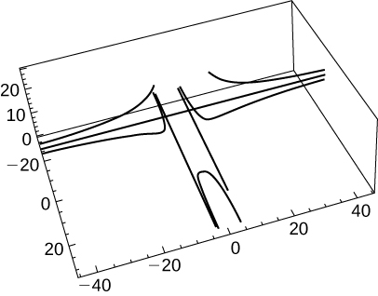

b. Undefined or infinite

**A particle moves on a circular path of radius *b* according to the function  where  is the angular velocity, **

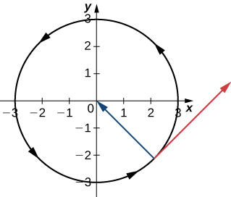

67. Find the velocity function and show that  is always orthogonal to 

Answer:  To show orthogonality, note that 

69. Evaluate  given 

Answer: 

71. Evaluate 

Answer: 

73. Show that if the speed of a particle traveling along a curve represented by a vector-valued function is constant, then the velocity function is always perpendicular to the acceleration function.

Answer: 

**The last statement implies that the velocity and acceleration are perpendicular or orthogonal.**

75. Given  find the velocity and the speed at any time.

Answer:  speed = 

77. Find the equation of the tangent line to the curve  at 

Answer: 

79. Locate the highest point on the curve  and give the value of the function at this point.

Answer:  at 

**The position vector for a particle is  The graph is shown here:**

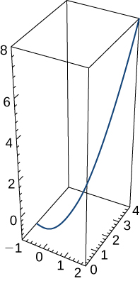

81. Find the speed of the particle at time  sec.

Answer: 

**Find the following:**

83. Velocity of the particle at any time

Answer: 

85. Acceleration of the particle at any time

Answer: 

**A particle travels along the path of an ellipse with the equation  Find the following:**

87. Velocity of the particle

Answer: 

89. Acceleration of the particle at 

Answer: 

**Given the vector-valued function  (graph is shown here), find the following:**

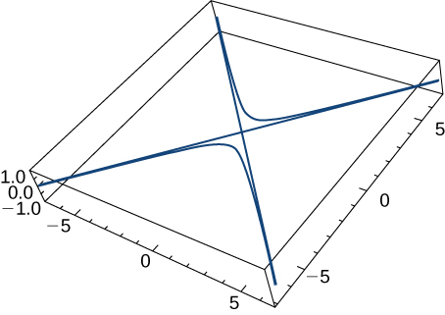

91. Speed

Answer: 

93. Find the minimum speed of a particle traveling along the curve 

Answer: 2

**Given  and  find the following:**

95. 

Answer: 

**Find the unit tangent vector T(t) for the following vector-valued functions.**

97.  The graph is shown here:

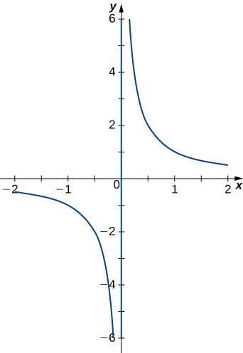

Answer: 

99. 

Answer: 

**Evaluate the following integrals:**

101.  where 

Answer: 

This file is copyright 2016, Rice University. All Rights Reserved.